* 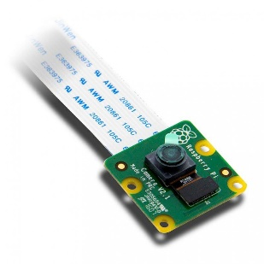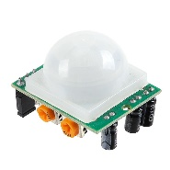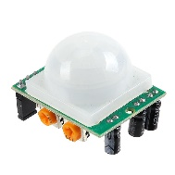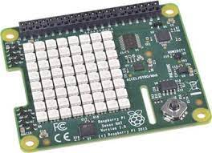A picture containing clipart

  Description automatically generated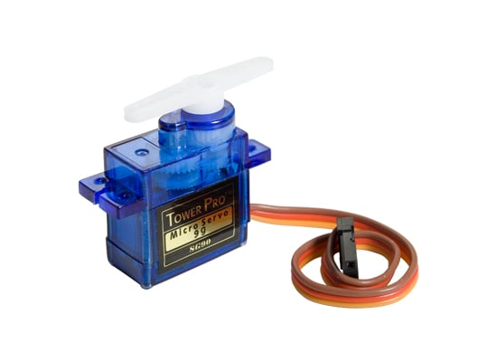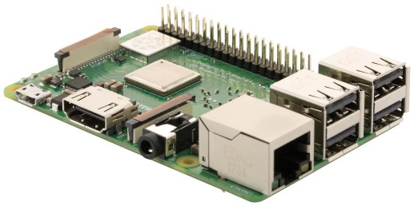

Glitch Web App with Email JS embedded script

-> **Image and link to web stream**

Email Notif (image and web stream link)

piCamera Module

Servo control from Blynk

PWM control

Image and DB entry to FB

Servo controller

Puppy crate lock

Pi running python script

Y-Axis PIR

Y-Axis PIR

X-Axis PIR

Firebase Storage and database

Sensehat Temp & Humidity

Phone running Blynk App

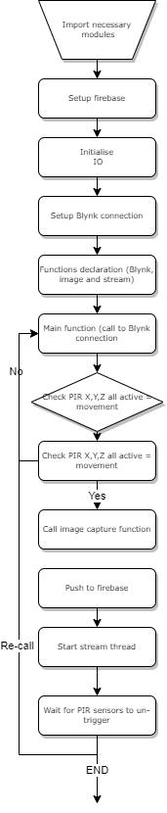**Flow diagram**: